Format Comments

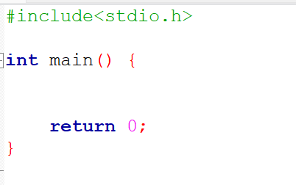 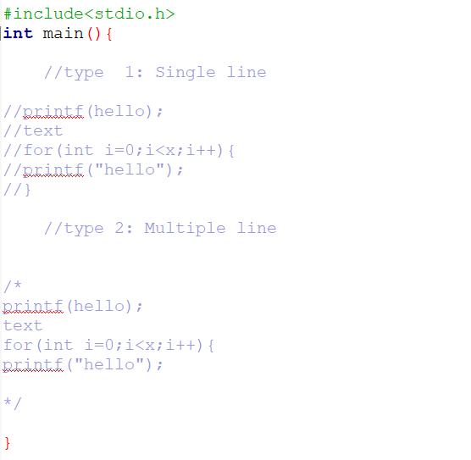

Data Types and variable

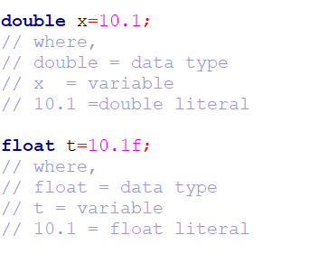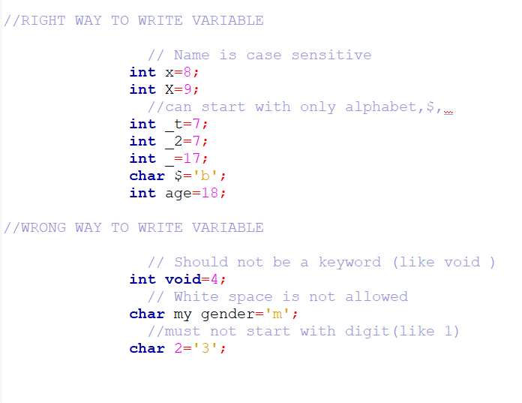



 initializing multiple similar datatype variable

Primitive Data Type

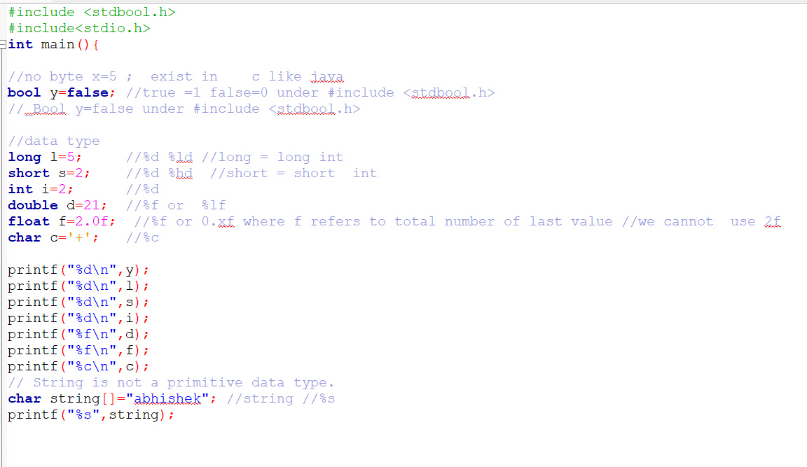

Scanner Class

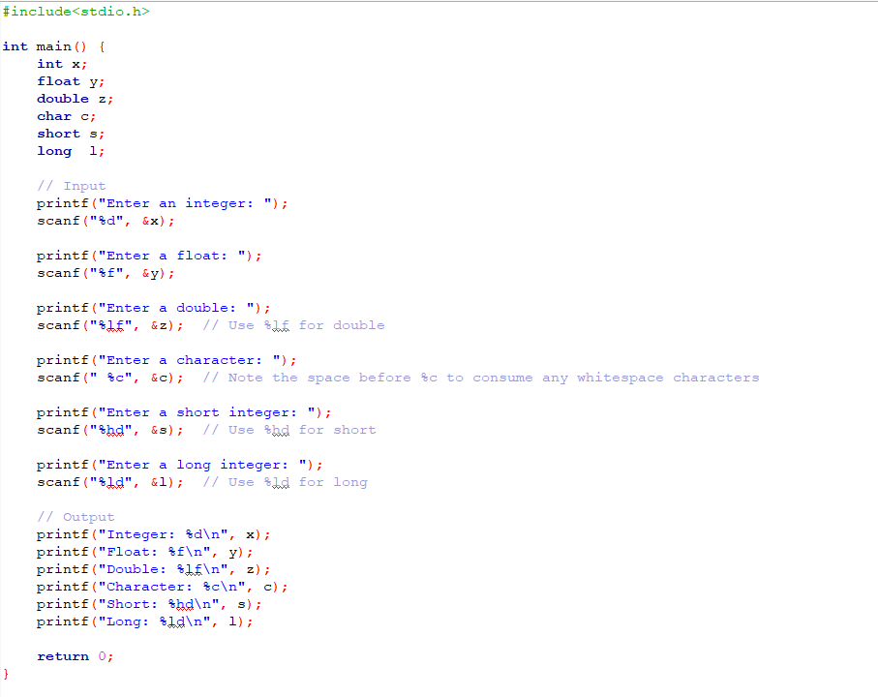

Multiple scan in one time Multiple printing in one time concept count in printf

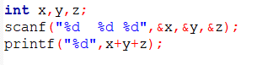 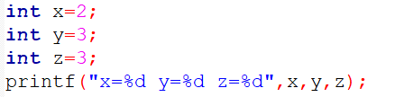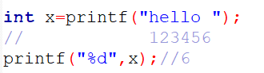

Scanning word vs sentence

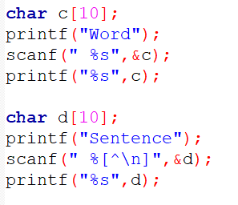 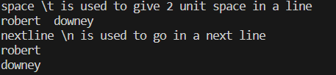

Wrong format to initialize to print % in sentence ascii value

 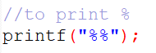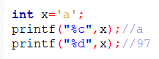

Data Type Conversion /widening/implicit conversion

short🡪int🡪 long🡪 float🡪double

Type Casting / Narrowing /Explicit Conversion

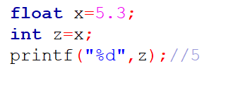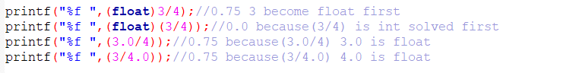

Operators

1. Arithmetic
2. Binary (mathematical) operator: + - * / %
3. Unary operator: ++x x++ --x x—
4. Ternary operator: ?:

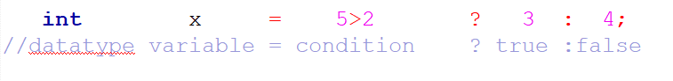

1. Relational ( == != > >= < <= )
2. Logical ( && || ! )
3. Assignment ( = += -= *= %= /=)
4. Bitwise (
5. &(bitwise and)
6. |(bitwise or)
7. <<(shift left)
8. >>(shift right)
9. ~(one’s complement)
10. ^(bitwise exclusive or) )

Bitwise Operator in detail

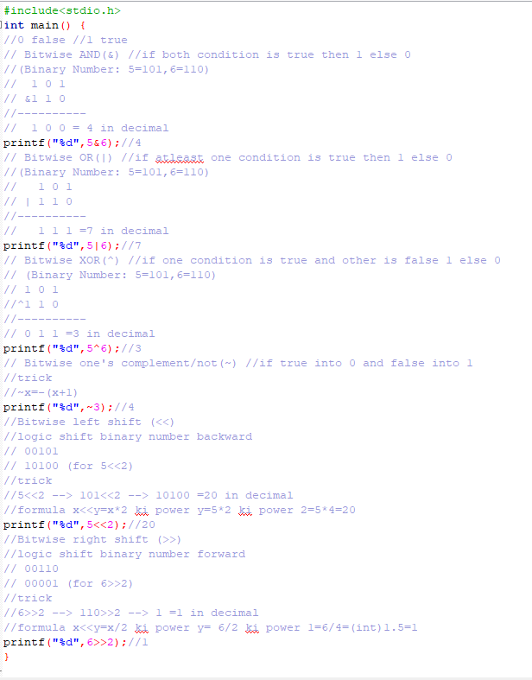







Break and Continue Statement

Break(to exit loop) Continue(to skip specific condition iteration)

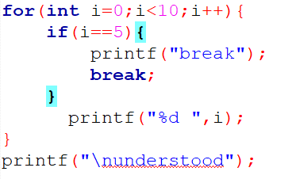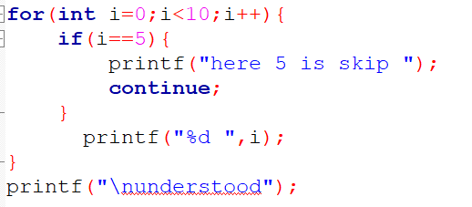

***Output: break***



***Output: continue***



Math function

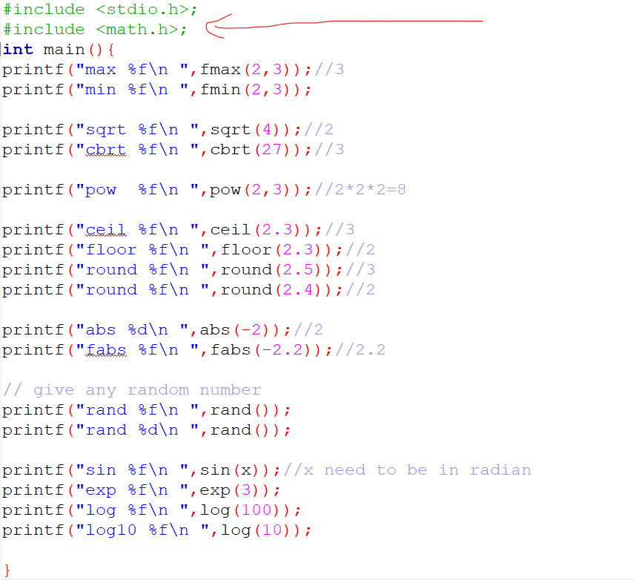

String Function

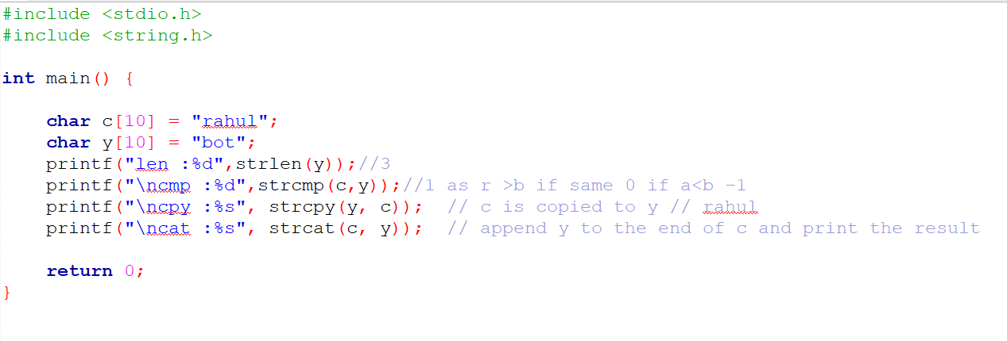

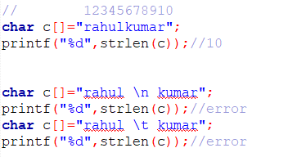

Conditional Branching/Selectional Control/Decision Making

If Statement if else Statement

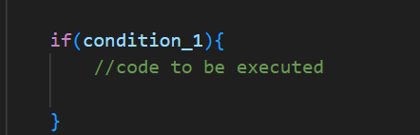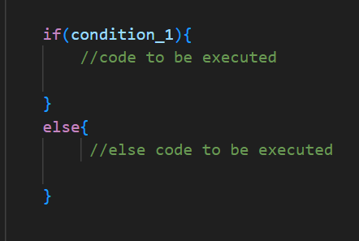

Else if Statement Nested if Statement

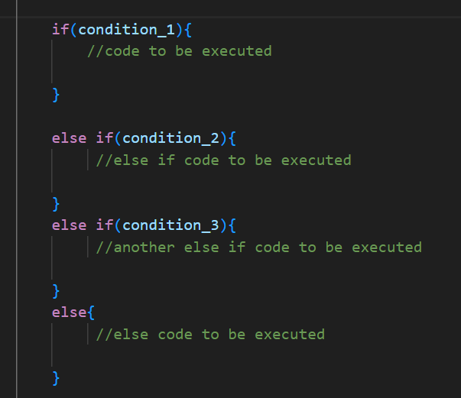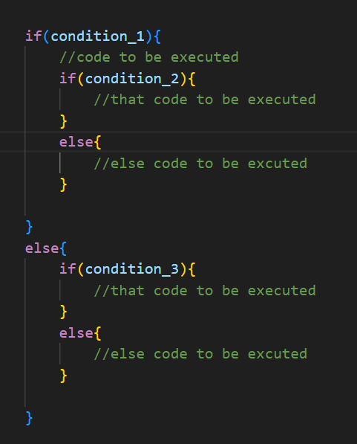

Switch statement

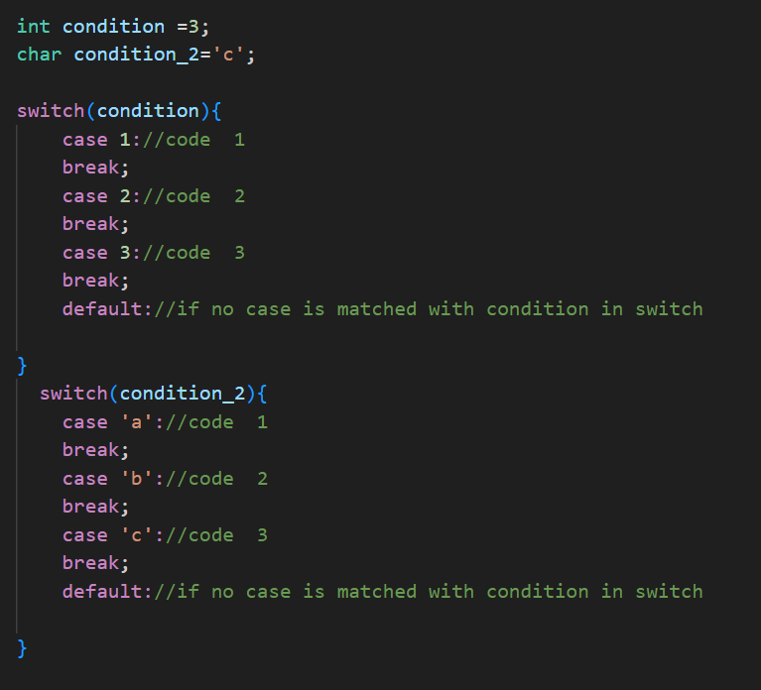

Loop Statement

1)Exit Controlled Loop/post tested loop (do while loop)

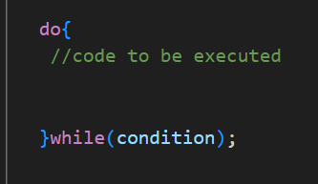

2)Entry Controlled Loop/pre tested loop (for loop, while loop)

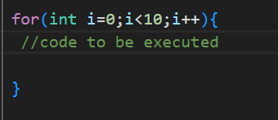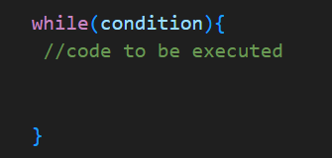

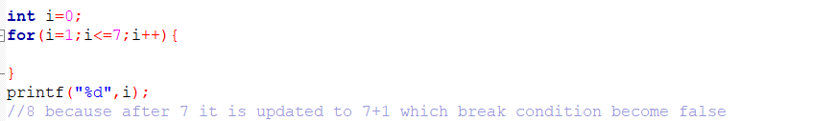

Function

* function overloading (same name different parameter or same name but parameter datatype different) is not supported in c

Here value is passed in function by call by value and call by reference.

# Call by value Call by reference

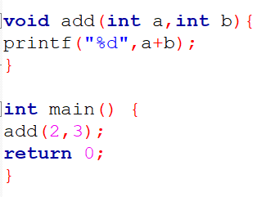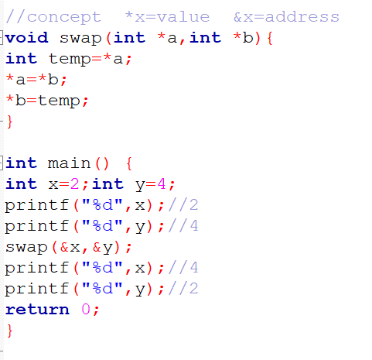

#Define

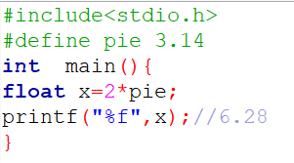

typedef

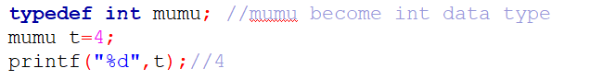

Array

*For understanding only*

1. *Int dim[row]*
2. *Int dim2[row][column]*
3. *Int dim3[depth][row][column] (generally not used but can be)*

* *Row=sizeof(dim)/sizeof(dim[0])*
* *Column= sizeof(dim[0])/sizeof(dim[0][0])*

One dimensional Array

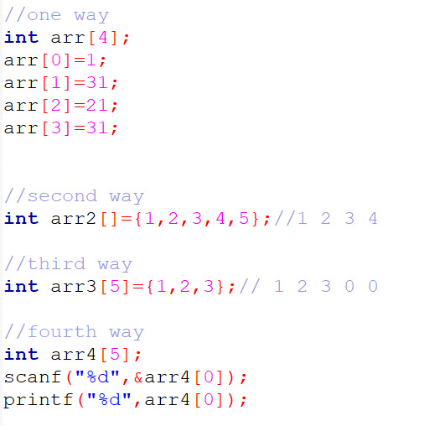

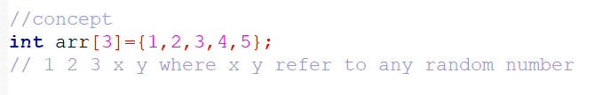

Multidimensional Array

2d and 3d array and many more

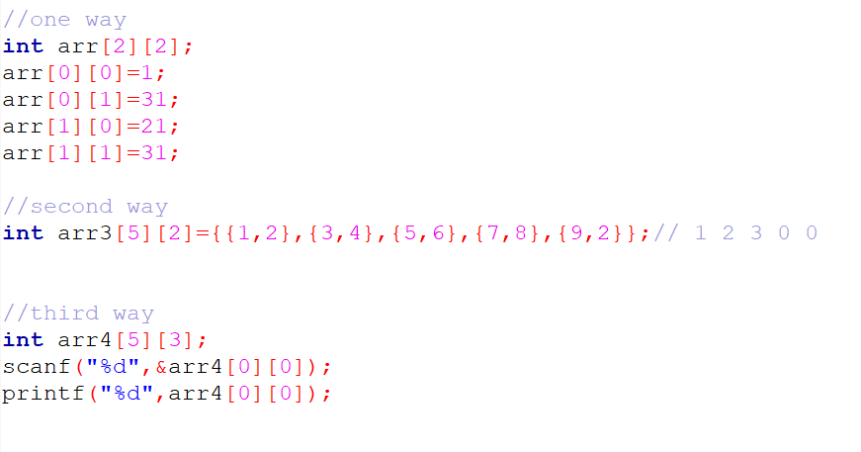

Recursion

1. Base case
2. Work
3. Inner case

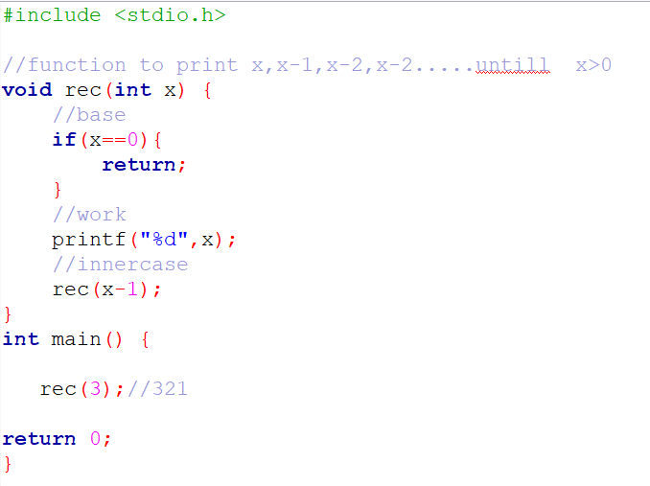

Structure

# In main Globally

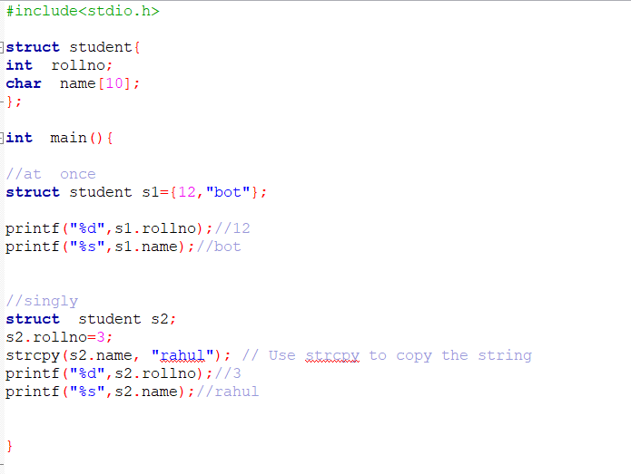 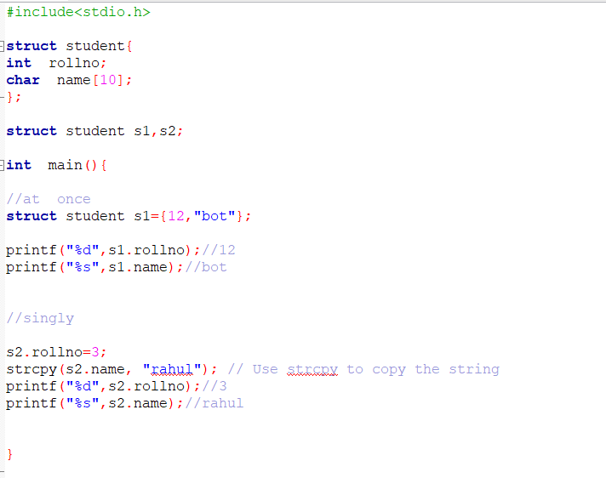

Union

# In main Globally

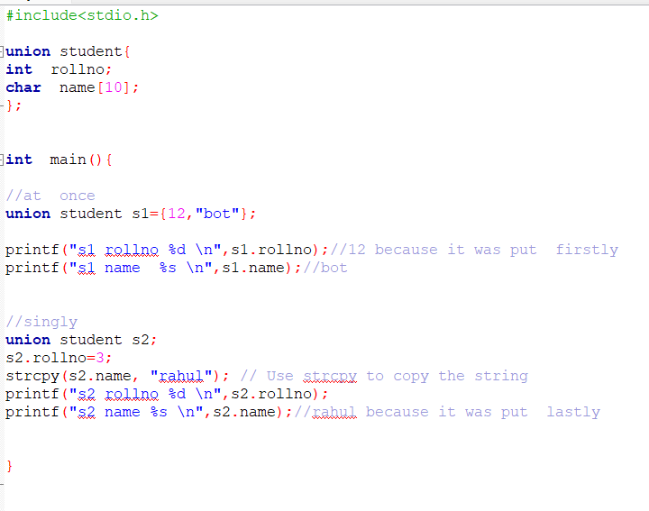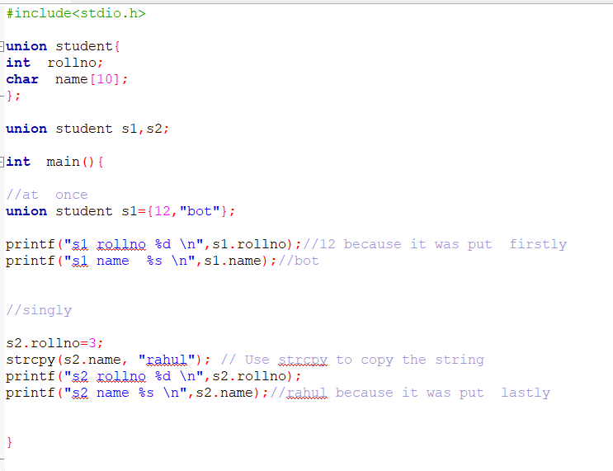

Pointer

# Declaration

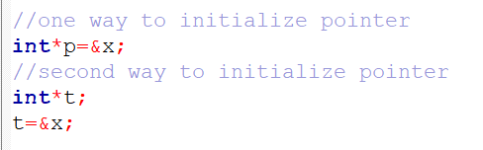

# Type of pointer : Pointer and Double Pointer

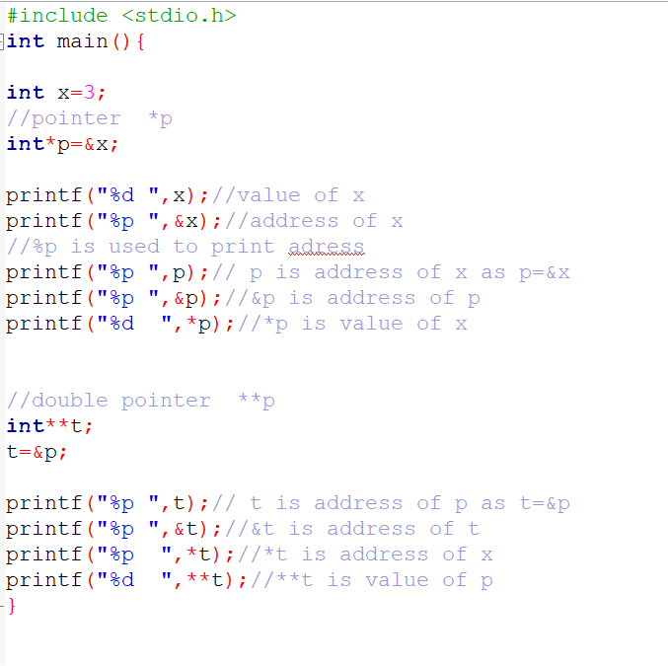

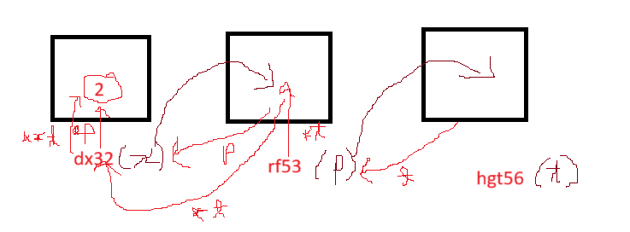

*p mean value of &x(address x)

*t mean value of &p(address p)

**t mean value of &x(address x)

Pointer to array

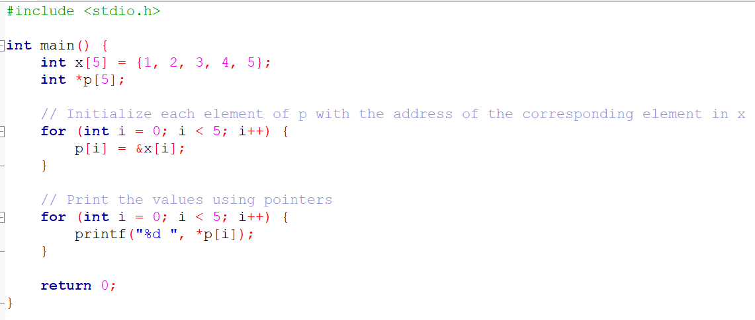

Pending topic

1. Pointer to function
2. Pointer to structure
3. Memory allocation
4. linked structure

5. file handling